**“ COAL WASTE MANAGEMENT”**

Submitted in 49TH Jawaharlal Nehru National Science, Mathematics and Environmental Exhibition for Children ----- 2022

JAWAHAR NAVODAYA VIDYALAYA, SARANG, DHENKANAL



GUIDED BY : PRATIMA MISHRA SUBMITTED BY : (PGT) CHEMISTRY

JYOTIRMAYA LENKA

CLASS : XI SCIENCE

ABSTRACT

Talcher is highly polluted town of Angul district of Odisha ,where the coal mines are present .With this environmental chemistry project I tried to resolve the problems of the locality in talcher .

Due to coal mining many types of pollution is present in Talcher. the aim of our project is –coal waste management .The average rainfall is compared to found 20mm less than last 10 years .average temperature rises by 5-7 degree Celsius from 1995 to 2020 . in this project we will find the causes of coal pollution and the harmful wastes crated from it . and the mitigations of this problem .our one of the solution to the problem is plantations ,reusing minning wastes etc.

“Coal and air pollution”

When coal burns, the chemical bonds holding its carbon atoms in place are broken, releasing

energy. However, other chemical reactions *also* occur, many of which carry toxic airborne pollutants and heavy metals into the environment. **Mercury**: Coal plants are responsible for [42 percent](https://www.epa.gov/sites/production/files/2016-12/documents/nei2014v1_tsd.pdf) of india mercury emissions, a toxic heavy metal that [can damage](http://www.who.int/mediacentre/factsheets/fs361/en/) the nervous, digestive, and immune systems, and is a serious threat to the child development. Just 1/70th of a teaspoon of mercury deposited on a 25-acre lake can make the fish unsafe to eat. According to the Environmental Protection Agency’s (EPA) [National Emissions Inventory](https://www.epa.gov/air-emissions-inventories/2014-national-emissions-inventory-nei-data), india coal power plants emitted 45,676  pounds of mercury in 2014 (the latest year data is available).

**Sulfur dioxide (SO2)**: Produced when the sulfur in coal reacts with oxygen, SO2 combines with other molecules in the atmosphere to form small, acidic particulates that can penetrate human lungs. It’s [linked](https://www.epa.gov/so2-pollution/sulfur-dioxide-basics#effects) with asthma, bronchitis, smog, and acid rain, which damages crops and other ecosystems, and acidifies lakes and streams. india coal power plants emitted more than 3.1 million tons of SO2 in 2014.

**Nitrogen oxides** (NO2): [Nitrous oxides](https://www.epa.gov/no2-pollution/basic-information-about-no2#Effects) are visible as smog and irritate lung tissue, exacerbate asthma, and make people more susceptible to chronic respiratory diseases like pneumonia and influenza. In 2014, india coal power plants emitted more than 1.5 million tons.

**Particulate matter**: Better known as “soot,” this is the ashy grey substance in coal smoke, and is [linked](https://www3.epa.gov/region1/airquality/pm-human-health.html) with chronic bronchitis, aggravated asthma, cardiovascular effects like heart attacks, and premature death. India coal power plants emitted 197,286 tons of small airborne particles (measured as 10 micrometers or less in diameter) in 2014..

Other harmful pollutants emitted in 2014 by the india coal power fleet include

* 41.2 tons of **lead**, 9,332 pounds of **cadmium,** and other **toxic heavy metals**.
* 576,185 tons of **carbon monoxide**, which causes headaches and places additional stress on people with heart disease. 22,124 tons of **volatile organic compounds** (VOC), which form ozone.

**GRAPH OF WASTEGENERATED**

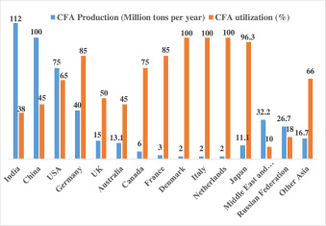

**MITIGATIONS OF COAL WASTE**

-Generation and propagation of dust is controlled at source by installation of fixed sprinklers at CHPS ,coal stockyards ,weighbridges and along transportation in roads .

- Mobile water sprinkler are deployed along the haul roads and road transport road

- Coal companies are deploying modern equipments having environment friendly features like surface miner in coal that eliminates the drilling,blasting and crushing operations in coals ,and obviates pollution caused due to these operations .

- We should use drills fitted with weight drilling and dust extractors in order to control generation of dust .

- To avoid spillage of coals from trucks on roads –all loaded coal transporting trucks are covered by tarpaulin .

- Transport haul roads should be more developed and maintained for better stability .

- First mile connectivity projects are being implemented for road transport through mechanical loadings and conveying systems .

- Avenue and peripheral plantation to arrest propagation and dispersion of dust significantly .

- Installation of wind barriers for dust trapping

REUSE AND RECYLING OF MINING WASTE

3.2 Clay Band Use : In surface mining method it is possible to mine bands like clay separately and then use them for making bricks, stemming material and potteries. Clay band at Kampti opencast mine in WCL is being used for such purposes.

3.3 Mine Water The water from underground mines which was initially discharged into local water bodies is now treated and used for drinking and industrial purpose. WCL has established a RO plant of capacity 10,000 liters per hour in Patansaongi village catering to drinking water needs of around 1,00,000 local populace. Additionally, the plant has a bottling facility through which “COAL NEER” brand of packaged drinking water is also being launched. Many subsidiaries of CIL are treating water and are supplying it to local townships and industrial units. Other subsidiaries of CIL have also started treating underground mine water and are supplying it to local townships and industries.

3.4 Eco Park There are many case studies in the mines of CIL wherein water bodies created from mining are converted to picnic spots. One such case study which has attracted attention of all is Eco park at Saoner underground mines lease hold area of WCL. The park utilizes mine water for gardening, water conservation, boating and amusement purposes. The park showcases several demonstrable technologies such as Solar electrification of water pump, Rain water harvesting, micro irrigation, etc. along with a science park and several adventure rides. The park also has an artificial mine tunnel showcasing different mining job profiles, machinery and methods used in the coal mines. The annual tourist footfall is more than 50,000

3.5 Iron Ore Tailings(IOT) Yelli shetty used iron ore waste from Goa and conducted an experimental study. In the concrete mix, 40% of coarse aggregates were replaced with iron ore tailings and concrete blocks were made for 28 days curing. It resulted in the compressive strength of 21.93MPa to that of granite aggregate of 19.91 MPa. Hence, the increase in the compressive strength was noticed with iron ore tailings with respect to the conventional coarse aggregat (8)

3.6 Iron Ore Waste Rock Gayana B C reported that the workability of all the concrete mixes increased upto 40%, where natural aggregate in concrete was replacement with iron ore overburden / waste rock along with upward trend in compressive strength

3.7 Fly Ash Fly ash is produced by coal-fired electric and steam generating plants. It is commonly used in Portland cement concrete for applications in highway construction, in soil improvement, as mineral filler in hot mixed asphalt and in grouts for pavement sub sealing. It is also used in making ash bricks and clinkers for stowing in underground mines

3.8 Blast Furnace slag Blast furnace slag is generated during the melting process in steel making operations. It is very as a cementitious binder in road construction. It is very commonly used road base material in France. In areas near to steel plants it is also used as aggregate in road construction.

3.9 Waste Dump Mining The low grade rejects of past which were dumped are now being mined for metal extraction. Common example is of manganese ore. The dumps created near Ramtek in Nagpur district are presently being mined. The grade of the ore is more than 20%.

**CFA RECYCLING GRAPH**

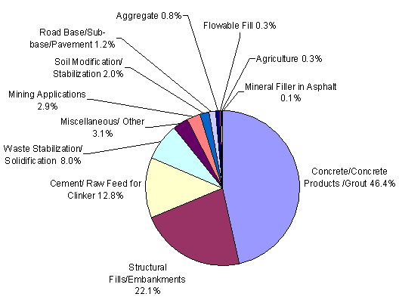

**“COAL WASTE AS USEFUL PRODUCT FOR OTHER INDUSTRIES ”**

Although we know that coal industries generate many harmful by products .these harmful products can be used in other industries which would result in minimizing coal waste generation. These waste can be treated as useful product for other industries like sugar, cement etc. in the given below I will note down how we can apply it .

1. The harmful s02 gas released in thermal power plants can be trapped using advance equipments .these gas can be treated as raw material for sugar industries . Coloured(mollases)→SO2​lighten(mollases). The reductive property of SO2​ is used in sugar industries, it is used to remove colour impurities and lighten the coloured molasses.
2. The 2 by products during coal mining are fly ash and bottom ash .these byproducts can be used by cement industries .they can be used to make concrete ,otherwise the govt may collect these waste and can use these as structural fill materials for construction of highways, embankments and backfilling abutments .

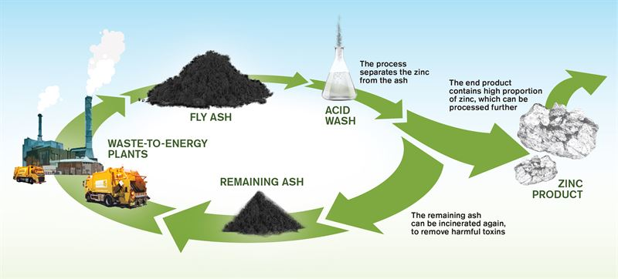

1. Another harmful gas produced in TTPC is nitrogen dioxide .in our local area talcher we can use advance techniques to entrap these gases and use it . it can be used in other chemical industries ,as chemical explosives ,production of nitric acids , they can be treated as rocket fuels .if this step could work it would help defence as well as the nation.
2. The coal industry not only generates the solid waste but it also releases harmful hot water into river which can harm aquatic life .we can treat this hot water in hot water treatment plants.

**ADVANTAGES OF COAL WASTE MANAGEMENT**

1-By using the above procedures we can control the air pollution ,the water pollution in the locality of talcher . if we aplly this in all india basis then we can control the pollution by thermal plants to a great extent .

2- This symbiosis realtion between plants can help the small industries and can agrrevate the development of small chemical industries .

3 –This can contribute a great to chemistry as well as environment if with the help of this above procedures we can manage the coal waste in Talcher.

**BIBILOGRAPHY**

I have completed this project by the help of

1. Chemistry teacher (pratima mishra)
2. Sites like fhwa.dot.gov
3. Link.springer.com
4. [Www.sciencedirect.com](http://Www.sciencedirect.com)

## Conclusion

We have seen that the people of Talcher are facing many respiratory diseases like asthma, chronic obstructive pulmonary disease (COPD). pulmonary fibrosis, pneumonia, and lung cancer. If the government will follow the above procedures then we can eradicate the pollution level inTalcher . It can help both the citizens ,environment as well as the nation .the waste recycling of the harmful by-products will help the small scale industries and can contribute to the employment generation as well as to the GDP of the country . With this environmental chemistry project I tried to eradicate the problems of the locality of Talcher.